PSG COLLEGE OF TECHNOLOGY, COIMBATORE – 641 004
Department of Applied Mathematics and Computational Sciences
MSc SOFTWARE SYSTEMS – Semester IV
20XW48 – Web Designing Lab
PROBLEM SHEET – CSS3 Basics

- Write a CSS rule to a web page with a background color (light gray) and a color (dark blue).
<!DOCTYPE html>
<html>
<style>
body
{
background-color:lightgrey;
color:blue;

}

</style>
<body>
<h1><center>hello</center></h1>
</body>

</html>

- Write a CSS rule that places a background image halfway down the page, tiling it horizontally and vertically. The image should remain in place when the user scrolls up or down.
<!DOCTYPE html>
<html>
<style>
img
{

transform:rotate(30deg);
position:fixed;
left:50%;
top:50%;
}

</style>
<body>

<img src="https://th.bing.com/th/id/OIP.ob00aaoI5lVGgQtvwzZNgAHaJ4?w=190&h=253&c=7&r=0&o=5&pid=1.7">

</body>

</html>
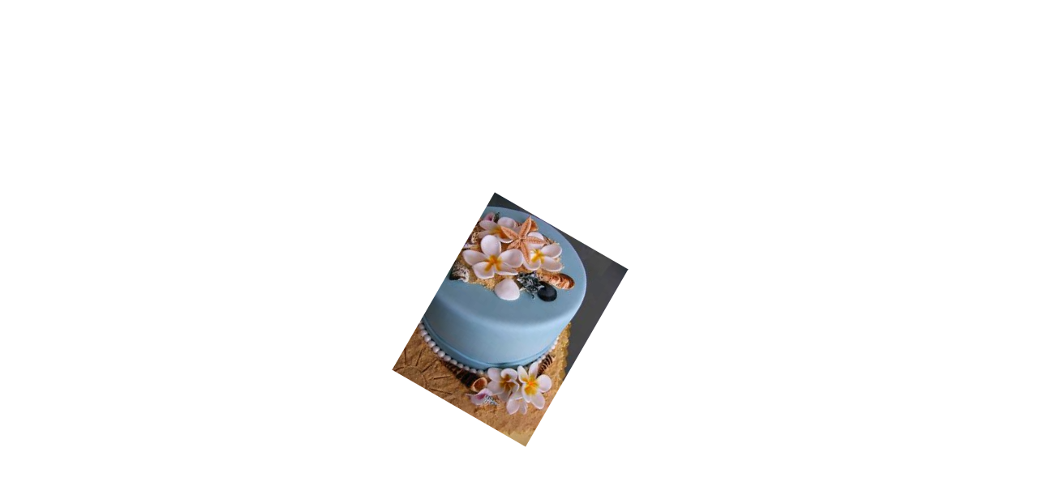
- Write the CSS code to display a page with background image with different “repeat” values and another image in the center of the page.

<!DOCTYPE html>
<html>
<style>
body
{
background-image:url("https://th.bing.com/th/id/OIP.ob00aaoI5lVGgQtvwzZNgAHaJ4?w=190&h=253&c=7&r=0&o=5&pid=1.7");

background-repeat:repeat;
}

img
{
position:absolute;
top:40%;
left:40%;
}

</style>
<body>
<img src=https://th.bing.com/th/id/OIP.abPwozVqbDwbS86sya16kAHaHa?w=177&h=180&c=7&r=0&o=5&pid=1.7">

</body>

</html>

- Create a page with three paragraphs and write the CSS code to put an image as background image in each one of the paragraphs.
<!DOCTYPE html>
<html>
<style>
#p1
{
background-image:url("https://th.bing.com/th/id/OIP.cb0fY5o0m-c-OlCv9lT2_gHaEK?w=322&h=181&c=7&r=0&o=5&pid=1.7");
}

#p2
{
background-image:url("https://th.bing.com/th/id/OIP.JSvy4U0Ahm94VzH1gFImhwHaEo?w=291&h=181&c=7&r=0&o=5&pid=1.7");
}

#p3
{
background-image:url("https://th.bing.com/th/id/OIP.cb0fY5o0m-c-OlCv9lT2_gHaEK?w=322&h=181&c=7&r=0&o=5&pid=1.7");
}
</style>
<body>
<p>
<div id="p1">
A paragraph (from Ancient Greek παράγραφος (parágraphos) 'to write beside') is a self-contained unit of discourse in writing dealing with a particular point or idea. A paragraph consists of one or more sentences. Though not required by the syntax of any language.A paragraph (from Ancient Greek παράγραφος (parágraphos) 'to write beside') is a self-contained unit of discourse in writing dealing with a particular point or idea. A paragraph consists of one or more sentences. Though not required by the syntax of any languageA paragraph (from Ancient Greek παράγραφος (parágraphos) 'to write beside') is a self-contained unit of discourse in writing dealing with a particular point or idea. A paragraph consists of one or more sentences. Though not required by the syntax of any languageA paragraph (from Ancient Greek παράγραφος (parágraphos) 'to write beside') is a self-contained unit of discourse in writing dealing with a particular point or idea. A paragraph consists of one or more sentences. Though not required by the syntax of any languageA paragraph (from Ancient Greek παράγραφος (parágraphos) 'to write beside') is a self-contained unit of discourse in writing dealing with a particular point or idea. A paragraph consists of one or more sentences. Though not required by the syntax of any languageA paragraph (from Ancient Greek παράγραφος (parágraphos) 'to write beside') is a self-contained unit of discourse in writing dealing with a particular point or idea. A paragraph consists of one or more sentences. Though not required by the syntax of any languageA paragraph (from Ancient Greek παράγραφος (parágraphos) 'to write beside') is a self-contained unit of discourse in writing dealing with a particular point or idea. A paragraph consists of one or more sentences. Though not required by the syntax of any language
</div>
</p>
<p>
<div id="p2">
A paragraph (from Ancient Greek παράγραφος (parágraphos) 'to write beside') is a self-contained unit of discourse in writing dealing with a particular point or idea. A paragraph consists of one or more sentences. Though not required by the syntax of any language
</div>

</p>
<p>
<div id="p3">
A paragraph (from Ancient Greek παράγραφος (parágraphos) 'to write beside') is a self-contained unit of discourse in writing dealing with a particular point or idea. A paragraph consists of one or more sentences. Though not required by the syntax of any language
</div>
</p>

</body>

</html>
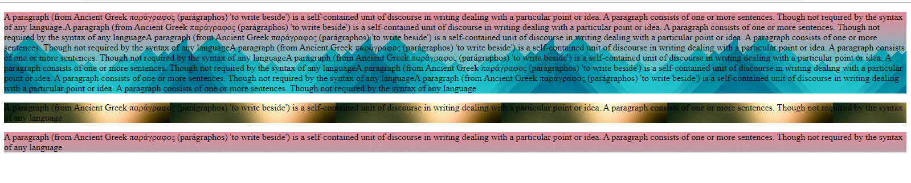
- Write a CSS rule to set the background color for block level element. Use different color models like color names, hexadecimal colors, rgb and others.
<!DOCTYPE html>
<html>
<style>
#p1
{
background-color:rgb(0,130,45);
}

#p2
{
background-color:#EA9B40;
}

#p3
{
background-color:red;
}
#p4
{
background-color:hsl(70,75%,80%);
}
</style>
<body>
<p>
<div id="p1">
A paragraph (from Ancient Greek παράγραφος (parágraphos) 'to write beside') is a self-contained unit of discourse in writing dealing with a particular point or idea. A paragraph consists of one or more sentences. Though not required by the syntax of any language.A paragraph (from Ancient Greek παράγραφος (parágraphos) 'to write beside') is a self-contained unit of discourse in writing dealing with a particular point or idea. A paragraph consists of one or more sentences. Though not required by the syntax of any languageA paragraph (from Ancient Greek παράγραφος (parágraphos) 'to write beside') is a self-contained unit of discourse in writing dealing with a particular point or idea. A paragraph consists of one or more sentences. Though not required by the syntax of any languageA paragraph (from Ancient Greek παράγραφος (parágraphos) 'to write beside') is a self-contained unit of discourse in writing dealing with a particular point or idea. A paragraph consists of one or more sentences. Though not required by the syntax of any languageA paragraph (from Ancient Greek παράγραφος (parágraphos) 'to write beside') is a self-contained unit of discourse in writing dealing with a particular point or idea. A paragraph consists of one or more sentences. Though not required by the syntax of any languageA paragraph (from Ancient Greek παράγραφος (parágraphos) 'to write beside') is a self-contained unit of discourse in writing dealing with a particular point or idea. A paragraph consists of one or more sentences. Though not required by the syntax of any languageA paragraph (from Ancient Greek παράγραφος (parágraphos) 'to write beside') is a self-contained unit of discourse in writing dealing with a particular point or idea. A paragraph consists of one or more sentences. Though not required by the syntax of any language
</div>
</p>
<p>
<div id="p2">
A paragraph (from Ancient Greek παράγραφος (parágraphos) 'to write beside') is a self-contained unit of discourse in writing dealing with a particular point or idea. A paragraph consists of one or more sentences. Though not required by the syntax of any language
A paragraph (from Ancient Greek παράγραφος (parágraphos) 'to write beside') is a self-contained unit of discourse in writing dealing with a particular point or idea. A paragraph consists of one or more sentences. Though not required by the syntax of any language.A paragraph (from Ancient Greek παράγραφος (parágraphos) 'to write beside') is a self-contained unit of discourse in writing dealing with a particular point or idea. A paragraph consists of one or more sentences. Though not required by the syntax of any languageA paragraph (from Ancient Greek παράγραφος (parágraphos) 'to write beside') is a self-contained unit of discourse in writing dealing with a particular point or idea. A paragraph consists of one or more sentences. Though not required by the syntax of any languageA paragraph (from Ancient Greek παράγραφος (parágraphos) 'to write beside') is a self-contained unit of discourse in writing dealing with a particular point or idea. A paragraph consists of one or more sentences. Though not required by the syntax of any languageA paragraph (from Ancient Greek παράγραφος (parágraphos) 'to write beside') is a self-contained unit of discourse in writing dealing with a particular point or idea. A paragraph consists of one or more sentences. Though not required by the syntax of any languageA paragraph (from Ancient Greek παράγραφος (parágraphos) 'to write beside') is a self-contained unit of discourse in writing dealing with a particular point or idea. A paragraph consists of one or more sentences. Though not required by the syntax of any languageA paragraph (from Ancient Greek παράγραφος (parágraphos) 'to write beside') is a self-contained unit of discourse in writing dealing with a particular point or idea. A paragraph consists of one or more sentences. Though not required by the syntax of any language

</div>

</p>
<p>
<div id="p3">
A paragraph (from Ancient Greek παράγραφος (parágraphos) 'to write beside') is a self-contained unit of discourse in writing dealing with a particular point or idea. A paragraph consists of one or more sentences. Though not required by the syntax of any language
A paragraph (from Ancient Greek παράγραφος (parágraphos) 'to write beside') is a self-contained unit of discourse in writing dealing with a particular point or idea. A paragraph consists of one or more sentences. Though not required by the syntax of any language.A paragraph (from Ancient Greek παράγραφος (parágraphos) 'to write beside') is a self-contained unit of discourse in writing dealing with a particular point or idea. A paragraph consists of one or more sentences. Though not required by the syntax of any languageA paragraph (from Ancient Greek παράγραφος (parágraphos) 'to write beside') is a self-contained unit of discourse in writing dealing with a particular point or idea. A paragraph consists of one or more sentences. Though not required by the syntax of any languageA paragraph (from Ancient Greek παράγραφος (parágraphos) 'to write beside') is a self-contained unit of discourse in writing dealing with a particular point or idea. A paragraph consists of one or more sentences. Though not required by the syntax of any languageA paragraph (from Ancient Greek παράγραφος (parágraphos) 'to write beside') is a self-contained unit of discourse in writing dealing with a particular point or idea. A paragraph consists of one or more sentences. Though not required by the syntax of any languageA paragraph (from Ancient Greek παράγραφος (parágraphos) 'to write beside') is a self-contained unit of discourse in writing dealing with a particular point or idea. A paragraph consists of one or more sentences. Though not required by the syntax of any languageA paragraph (from Ancient Greek παράγραφος (parágraphos) 'to write beside') is a self-contained unit of discourse in writing dealing with a particular point or idea. A paragraph consists of one or more sentences. Though not required by the syntax of any language
A paragraph (from Ancient Greek παράγραφος (parágraphos) 'to write beside') is a self-contained unit of discourse in writing dealing with a particular point or idea. A paragraph consists of one or more sentences. Though not required by the syntax of any language.A paragraph (from Ancient Greek παράγραφος (parágraphos) 'to write beside') is a self-contained unit of discourse in writing dealing with a particular point or idea. A paragraph consists of one or more sentences. Though not required by the syntax of any languageA paragraph (from Ancient Greek παράγραφος (parágraphos) 'to write beside') is a self-contained unit of discourse in writing dealing with a particular point or idea. A paragraph consists of one or more sentences. Though not required by the syntax of any languageA paragraph (from Ancient Greek παράγραφος (parágraphos) 'to write beside') is a self-contained unit of discourse in writing dealing with a particular point or idea. A paragraph consists of one or more sentences. Though not required by the syntax of any languageA paragraph (from Ancient Greek παράγραφος (parágraphos) 'to write beside') is a self-contained unit of discourse in writing dealing with a particular point or idea. A paragraph consists of one or more sentences. Though not required by the syntax of any languageA paragraph (from Ancient Greek παράγραφος (parágraphos) 'to write beside') is a self-contained unit of discourse in writing dealing with a particular point or idea. A paragraph consists of one or more sentences. Though not required by the syntax of any languageA paragraph (from Ancient Greek παράγραφος (parágraphos) 'to write beside') is a self-contained unit of discourse in writing dealing with a particular point or idea. A paragraph consists of one or more sentences. Though not required by the syntax of any language
</div>
</p>

<p>
<div id="p4">
A paragraph (from Ancient Greek παράγραφος (parágraphos) 'to write beside') is a self-contained unit of discourse in writing dealing with a particular point or idea. A paragraph consists of one or more sentences. Though not required by the syntax of any language
A paragraph (from Ancient Greek παράγραφος (parágraphos) 'to write beside') is a self-contained unit of discourse in writing dealing with a particular point or idea. A paragraph consists of one or more sentences. Though not required by the syntax of any language.A paragraph (from Ancient Greek παράγραφος (parágraphos) 'to write beside') is a self-contained unit of discourse in writing dealing with a particular point or idea. A paragraph consists of one or more sentences. Though not required by the syntax of any languageA paragraph (from Ancient Greek παράγραφος (parágraphos) 'to write beside') is a self-contained unit of discourse in writing dealing with a particular point or idea. A paragraph consists of one or more sentences. Though not required by the syntax of any languageA paragraph (from Ancient Greek παράγραφος (parágraphos) 'to write beside') is a self-contained unit of discourse in writing dealing with a particular point or idea. A paragraph consists of one or more sentences. Though not required by the syntax of any languageA paragraph (from Ancient Greek παράγραφος (parágraphos) 'to write beside') is a self-contained unit of discourse in writing dealing with a particular point or idea. A paragraph consists of one or more sentences. Though not required by the syntax of any languageA paragraph (from Ancient Greek παράγραφος (parágraphos) 'to write beside') is a self-contained unit of discourse in writing dealing with a particular point or idea. A paragraph consists of one or more sentences. Though not required by the syntax of any languageA paragraph (from Ancient Greek παράγραφος (parágraphos) 'to write beside') is a self-contained unit of discourse in writing dealing with a particular point or idea. A paragraph consists of one or more sentences. Though not required by the syntax of any language
A paragraph (from Ancient Greek παράγραφος (parágraphos) 'to write beside') is a self-contained unit of discourse in writing dealing with a particular point or idea. A paragraph consists of one or more sentences. Though not required by the syntax of any language.A paragraph (from Ancient Greek παράγραφος (parágraphos) 'to write beside') is a self-contained unit of discourse in writing dealing with a particular point or idea. A paragraph consists of one or more sentences. Though not required by the syntax of any languageA paragraph (from Ancient Greek παράγραφος (parágraphos) 'to write beside') is a self-contained unit of discourse in writing dealing with a particular point or idea. A paragraph consists of one or more sentences. Though not required by the syntax of any languageA paragraph (from Ancient Greek παράγραφος (parágraphos) 'to write beside') is a self-contained unit of discourse in writing dealing with a particular point or idea. A paragraph consists of one or more sentences. Though not required by the syntax of any languageA paragraph (from Ancient Greek παράγραφος (parágraphos) 'to write beside') is a self-contained unit of discourse in writing dealing with a particular point or idea. A paragraph consists of one or more sentences. Though not required by the syntax of any languageA paragraph (from Ancient Greek παράγραφος (parágraphos) 'to write beside') is a self-contained unit of discourse in writing dealing with a particular point or idea. A paragraph consists of one or more sentences. Though not required by the syntax of any languageA paragraph (from Ancient Greek παράγραφος (parágraphos) 'to write beside') is a self-contained unit of discourse in writing dealing with a particular point or idea. A paragraph consists of one or more sentences. Though not required by the syntax of any language
</div>
</p>

</body>

</html>
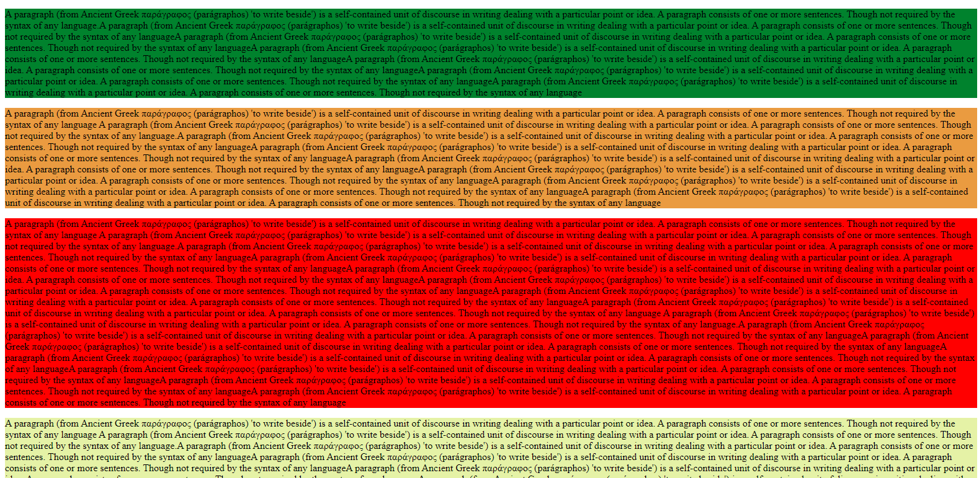
- Write a CSS code using different text properties to add some special styles to make the headings stand out more from the main text and also make the text in the paragraphs look more clean and attractive.
<!DOCTYPE html>
<html>
<style>
#p1
{
color:rebeccapurple;
background-color: aquamarine;
text-align: center;

font-family: 'Lucida Sans', 'Lucida Sans Regular', 'Lucida Grande', 'Lucida Sans Unicode', Geneva, Verdana, sans-serif;
text-decoration: double;
}
h1
{
color: blue;
text-align: center;
font-size: large;
font-family: 'Segoe UI', Tahoma, Geneva, Verdana, sans-serif;
text-decoration: double;
text-shadow: 1px 1px;
}
</style>
<body>
<h1>Sample text</h1>

<div id="p1">
<p>
Lorem ipsum dolor sit amet, consectetur adipiscing elit. Pellentesque feugiat cursus porta. Phasellus egestas, quam eget maximus tristique, orci dolor gravida mi, in tempus leo ex congue sem. Cras ut tempor ligula, vel luctus velit. Fusce pharetra enim et nulla porta, quis rutrum lacus dapibus. Sed in dapibus ex, ut blandit leo. Donec ac tincidunt magna. Duis et varius mi. Sed sed nulla ligula. Morbi tellus elit, accumsan sed euismod et, pulvinar nec quam. Sed ultrices tortor velit.

Nam in enim est. Nulla at pretium elit. Fusce ipsum est, suscipit et lectus non, lobortis accumsan augue. Nullam id gravida enim. Vivamus et enim ac purus condimentum finibus at ac metus. Duis rhoncus ipsum id nunc ultricies egestas. Morbi sed sapien sapien. Etiam eget rutrum erat, ut vulputate tellus. Maecenas in felis sed mauris volutpat condimentum. Ut ac auctor ipsum. Donec porttitor quam tincidunt ornare ultricies. Nullam gravida et sapien sed sollicitudin. Duis et quam pellentesque, congue dui eu, molestie quam.
</p>
</div>
</body>
</html>
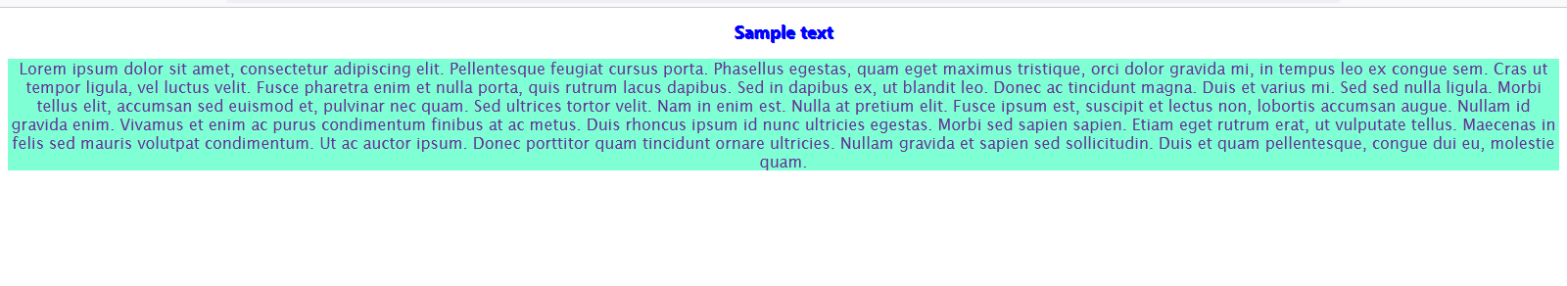
- Write a CSS rule that makes all text 1.5 times larger than the base font of the system and color it red.
<!DOCTYPE html>
<html>
<style>
#p1
{
color:rgb(226, 10, 10);

text-align: center;
font-size: 150%;
font-family: 'Lucida Sans', 'Lucida Sans Regular', 'Lucida Grande', 'Lucida Sans Unicode', Geneva, Verdana, sans-serif;
text-decoration: double;
}
h1
{
color: rgb(238, 17, 54);
text-align: center;
font-size: medium;
font-family: 'Segoe UI', Tahoma, Geneva, Verdana, sans-serif;
text-decoration: double;
text-shadow: 1px 1px;
}
</style>
<body>
<h1>Sample text</h1>

<div id="p1">
<p>
Lorem ipsum dolor sit amet, consectetur adipiscing elit. Pellentesque feugiat cursus porta. Phasellus egestas, quam eget maximus tristique, orci dolor gravida mi, in tempus leo ex congue sem. Cras ut tempor ligula, vel luctus velit. Fusce pharetra enim et nulla porta, quis rutrum lacus dapibus. Sed in dapibus ex, ut blandit leo. Donec ac tincidunt magna. Duis et varius mi. Sed sed nulla ligula. Morbi tellus elit, accumsan sed euismod et, pulvinar nec quam. Sed ultrices tortor velit.

Nam in enim est. Nulla at pretium elit. Fusce ipsum est, suscipit et lectus non, lobortis accumsan augue. Nullam id gravida enim. Vivamus et enim ac purus condimentum finibus at ac metus. Duis rhoncus ipsum id nunc ultricies egestas. Morbi sed sapien sapien. Etiam eget rutrum erat, ut vulputate tellus. Maecenas in felis sed mauris volutpat condimentum. Ut ac auctor ipsum. Donec porttitor quam tincidunt ornare ultricies. Nullam gravida et sapien sed sollicitudin. Duis et quam pellentesque, congue dui eu, molestie quam.
</p>
</div>
</body>
</html>
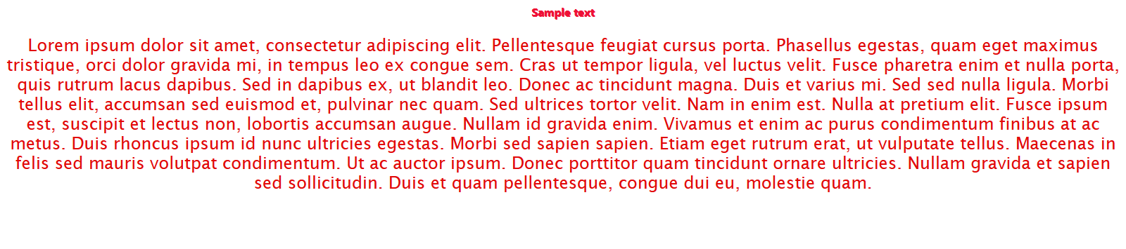
- Create a CSS rule that changes the effect of an EM element from italic text to underlined text.
<!DOCTYPE html>
<html>
<style>
em
{
text-decoration: underline;
}
</style>
<body>
<h1><center>Sample text</center></h1>

<div id="p1">
<em>
Lorem ipsum dolor sit amet, consectetur adipiscing elit. Pellentesque feugiat cursus porta. Phasellus egestas, quam eget maximus tristique, orci dolor gravida mi, in tempus leo ex congue sem. Cras ut tempor ligula, vel luctus velit. Fusce pharetra enim et nulla porta, quis rutrum lacus dapibus. Sed in dapibus ex, ut blandit leo. Donec ac tincidunt magna. Duis et varius mi. Sed sed nulla ligula. Morbi tellus elit, accumsan sed euismod et, pulvinar nec quam. Sed ultrices tortor velit.

Nam in enim est. Nulla at pretium elit. Fusce ipsum est, suscipit et lectus non, lobortis accumsan augue. Nullam id gravida enim. Vivamus et enim ac purus condimentum finibus at ac metus. Duis rhoncus ipsum id nunc ultricies egestas. Morbi sed sapien sapien. Etiam eget rutrum erat, ut vulputate tellus. Maecenas in felis sed mauris volutpat condimentum. Ut ac auctor ipsum. Donec porttitor quam tincidunt ornare ultricies. Nullam gravida et sapien sed sollicitudin. Duis et quam pellentesque, congue dui eu, molestie quam.
</em>
</div>
</body>
</html>
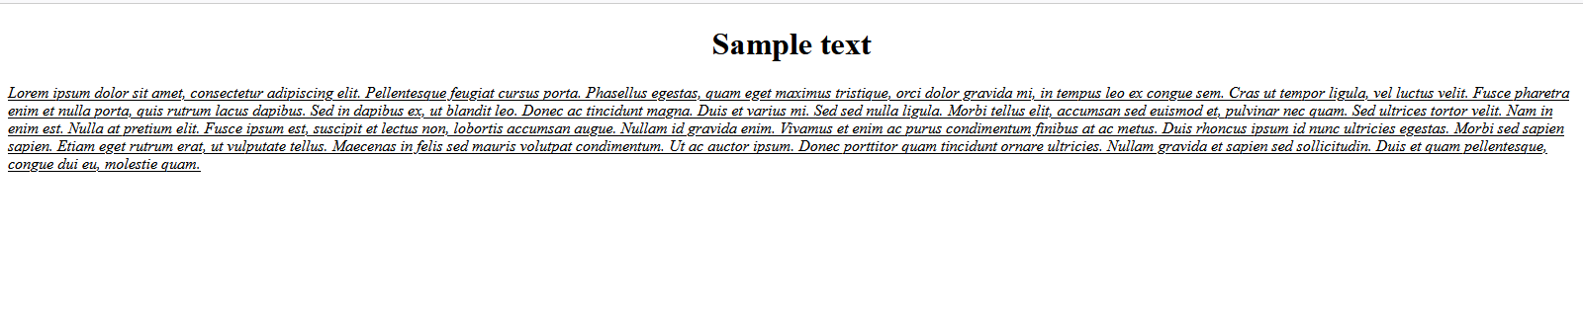
- Write a CSS rule that changes the color of all elements with attribute CLASS=”greenMove” to green and shifts them down 25 pixels and right 15 pixels.
<!DOCTYPE html>
<html>
<head>
<style type="text/css">
.greenMove
{
color: green;
position: relative;
top: 25 px;
left: 15 px;
}
</style>
</head>

<body>
<h1> Normal text
<span class="greenMove">Text with class greenMove</span>
</h1>
</body></html>

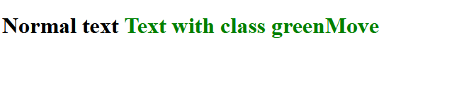
- Design a webpage with three titles and four paragraph as shown below:
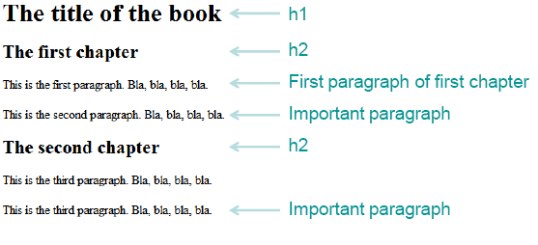
Write the CSS rule as following:
- The main title (h1) is color white on black
- The chapter titles (h2) are blue on yellow
- The default color of paragraphs is green
- The first paragraph of the first chapter is black
- An important paragraph is yellow on red
<!DOCTYPE html>
<html>
<head>
<style>
h1{
color: white;
background-color: black;
}
h2
{
color: blue;
background-color: yellow;
}
p
{
color: green;
}
#fpfc
{
color: black;
}
#imp
{
color: yellow;
background-color: red;
}
</style>
</head>

<body>
<h1>The Da Vinci Code</h1>
<h2>Chapter 1</h2>
<p>
<div id="fpfc">
A murder inside the Louvre, and clues in Da Vinci paintings, lead to the discovery of a religious mystery protected by a secret society for two thousand years, which could shake the foundations of Christianity.
</div>
</p>

<p>
<div id="imp">
Dan Brown's controversial best-selling novel about a powerful secret that's been kept under wraps for thousands of years comes to the screen in this suspense thriller from Director Ron Howard. The stately silence of Paris' Louvre museum is broken when one of the gallery's leading curators is found dead on the grounds, with strange symbols carved into his body and left around the spot where he died. Hoping to learn the significance of the symbols, police bring in Sophie Neveu (Audrey Tautou), a gifted cryptographer who is also the victim's granddaughter. Needing help, Sophie calls on Robert Langdon (Tom Hanks), a leading symbologist from the United States. As Sophie and Robert dig deeper into the case, they discover the victim's involvement in the Priory of Sion, a secret society whose members have been privy to forbidden knowledge dating back to the birth of Christianity. In their search, Sophie and Robert happen upon evidence that could lead to the final resting place of the Holy Grail, while members of the priory and an underground Catholic society known as Opus Dei give chase, determined to prevent them from sharing their greatest secrets with the world.
</div>
</p>
<p>
Dan Brown's controversial best-selling novel about a powerful secret that's been kept under wraps for thousands of years comes to the screen in this suspense thriller from Director Ron Howard. The stately silence of Paris' Louvre museum is broken when one of the gallery's leading curators is found dead on the grounds, with strange symbols carved into his body and left around the spot where he died. Hoping to learn the significance of the symbols, police bring in Sophie Neveu (Audrey Tautou), a gifted cryptographer who is also the victim's granddaughter. Needing help, Sophie calls on Robert Langdon (Tom Hanks), a leading symbologist from the United States. As Sophie and Robert dig deeper into the case, they discover the victim's involvement in the Priory of Sion, a secret society whose members have been privy to forbidden knowledge dating back to the birth of Christianity. In their search, Sophie and Robert happen upon evidence that could lead to the final resting place of the Holy Grail, while members of the priory and an underground Catholic society known as Opus Dei give chase, determined to prevent them from sharing their greatest secrets with the world.
</p>
<h2>
Second chapter
</h2>
<p>
<div id="imp">
Professor Robert Langdon is in Paris on business when he's summoned to The Louvre. A dead body has been found, setting Langdon off on an adventure as he attempts to unravel an ancient code and uncover the greatest mystery of all time.
</div>
</p>
</body>
</html>
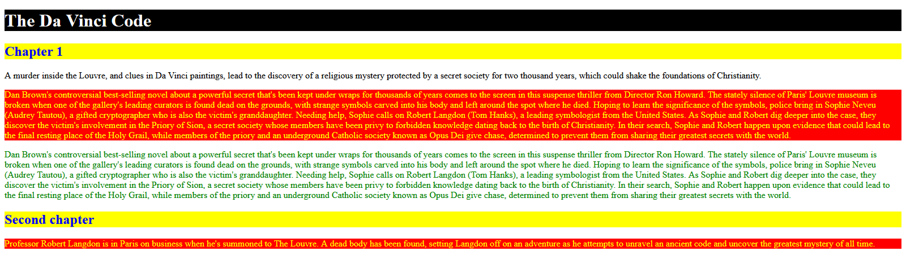
- Write CSS code to implement the following :
      - Colorize text of a paragraph where RGB value is (51, 204, 0).
      - Put a background image called BKG.GIF behind a single word “TEXT” written with a font size of 39 pixels.
      - Place an image in the background of a page such that the image tiles only in the horizontal direction and the starting position is the horizontal and vertical center of the page.
<!DOCTYPE html>
<html lang="en">
<head>
<meta charset="UTF-8">
<meta http-equiv="X-UA-Compatible" content="IE=edge">
<meta name="viewport" content="width=device-width, initial-scale=1.0">
<link rel="stylesheet" href="styles.css">
<title>Document</title>
</head>
<body>
<p>Lorem ipsum dolor sit <span>Text</span> amet consectetur, adipisicing elit. Dolorum pariatur voluptates reiciendis ab officiis. Magni eum pariatur aspernatur repudiandae fugiat vitae. Quis odit tempore sed voluptatum obcaecati repellat, accusamus numquam.</p>
<div class="d1">

<div class="d2"></div>
</div>
</body>
</html>
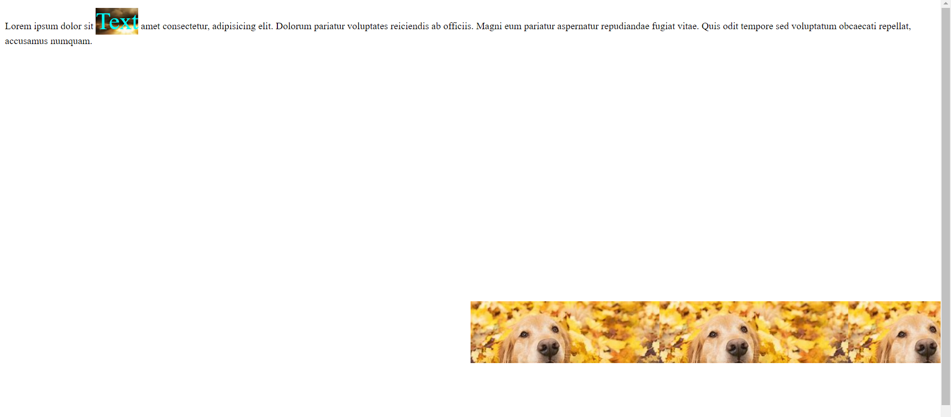
- Write CSS code to implement the following :
A border around an image element such that the top and bottom borders are 3 pixels wide and of type “dashed” while the left and right borders are 5 pixels wide and of type “solid”. All borders are green in color.
<!DOCTYPE html>
<html lang="en">
<head>
<meta charset="UTF-8">
<meta http-equiv="X-UA-Compatible" content="IE=edge">
<meta name="viewport" content="width=device-width, initial-scale=1.0">
<title>Document</title>
</head>
<style>
img
{
width: 50%;
border-top: 3px dashed;
border-bottom: 3px dashed;
border-left: 5px solid;
border-right: 5px solid;
padding: 5px;
border-color: green;
}
</style>
<body>
<img src="https://images.pexels.com/photos/60597/dahlia-red-blossom-bloom-60597.jpeg?auto=compress&cs=tinysrgb&dpr=1&w=500" alt="">

</body>
</html>
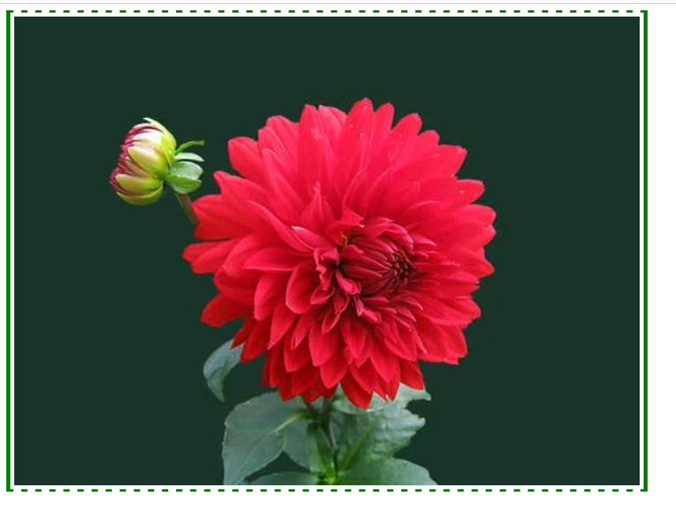

- Write the CSS code for an image 100 by 100 pixels in dimension and place it at the center of a page. Arrange to change the shape of the cursor to a “crosshair” when positioned over the image.
<!DOCTYPE html>
<html lang="en">
<head>
<meta charset="UTF-8">
<meta http-equiv="X-UA-Compatible" content="IE=edge">
<meta name="viewport" content="width=device-width, initial-scale=1.0">
<link rel="stylesheet" href="styles.css">
<title>Document</title>
</head>

<style>

img:hover
{
cursor: crosshair;
height:100px;
width:100px;
}
</style>

<body>
<center>
<img src="https://r1.ilikewallpaper.net/iphone-wallpapers/download/84488/silhouette-of-palm-tree-during-golden-hour-iphone-wallpaper-ilikewallpaper_com.jpg" height="100px" width="100px" alt="">
</center>
</body>
</html>

- Use CSS to write the text string “Cascading Style Sheet” dark red in color and in small caps as in a size that approximately covers 50% of the page width. The text should be a hyperlink pointing to a file STYLE.HTM, but without any underline. The stylesheet should remain in an external file.
<!DOCTYPE html>
<html lang="en">
<head>
<meta charset="UTF-8">
<meta http-equiv="X-UA-Compatible" content="IE=edge">
<meta name="viewport" content="width=device-width, initial-scale=1.0">
<link rel="stylesheet" href="styles.css">
<title>Document</title>
</head>
<body>
<a href="\ws5\q13\index.html">Cascading Style Sheet</a>
</body>
</html>

STYLE SHEET
a{
text-decoration: none;
color: red;
font-size: 50px;
}
- Write the CSS rule to display the webpage as shown below
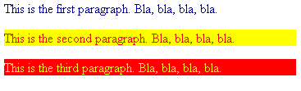

<!DOCTYPE html>
<html lang="en">
<head>
<meta charset="UTF-8">
<meta http-equiv="X-UA-Compatible" content="IE=edge">
<meta name="viewport" content="width=device-width, initial-scale=1.0">
<style>
#para1 {
color: blue;
}
#para2 {
background-color: yellow;
color: red;
}
#para3 {
background-color: red;
color: yellow;
}
</style>
<title>Document</title>
</head>
<body>
<p id="para1">This is the first paragraph.Bla,bla,bla</p>
<p id="para2">This is the second paragraph.Bla,Bla,Bla</p>
<p id="para3">This is the third paragraph.Bla, Bla,Bla</p>
</body>
</html>
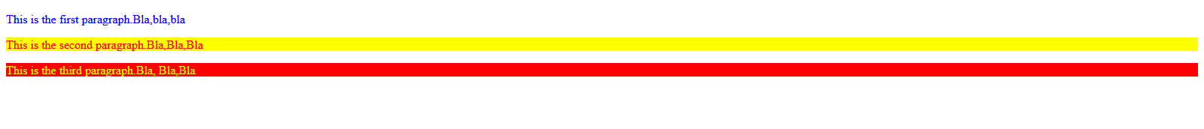

- Replicate the following Web page using CSS
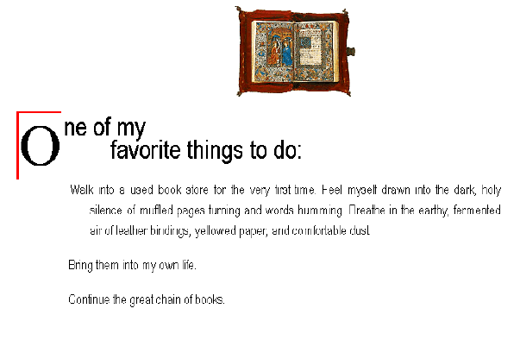
<!DOCTYPE html>
<html lang="en">

<head>
<meta charset="UTF-8">
<meta http-equiv="X-UA-Compatible" content="IE=edge">
<meta name="viewport" content="width=device-width, initial-scale=1.0">
<title>Document</title>
<style>
* {
margin: 0;
}

body {
height: 100vh;
display: flex;
flex-direction: column;
align-items: center;
}

img {
height: 100px;
}

.text {
width: 600px;
}

.title {
font-size: 2em;
font-weight: bold;
white-space: pre-line;
}

.title::first-letter {
font-size: 2em;
border-top: 2px solid red;
border-left: 4px solid red;
}
</style>
</head>

<body>
<div class="img-container">
<img src="https://preview.redd.it/j48o3wj5bqj11.png?auto=webp&s=123ad465c15be71faebe0005d0b9de0497450afa"
alt="">
</div>
<div class="text">
<p class="title">One of my favorite things to do:</p>
<p>
Lorem ipsum dolor sit amet consectetur adipisicing elit. Eligendi, ipsa et libero eaque iusto vitae
dignissimos, assumenda dolor recusandae magnam sapiente excepturi earum deleniti saepe. Possimus laboriosam
alias ea commodi? Molestiae quia voluptatum quos doloremque incidunt aliquam illum ullam iste enim. Cum
error provident deserunt ullam! Recusandae dolorem doloremque quod.
</p>
</div>

</body>

</html>
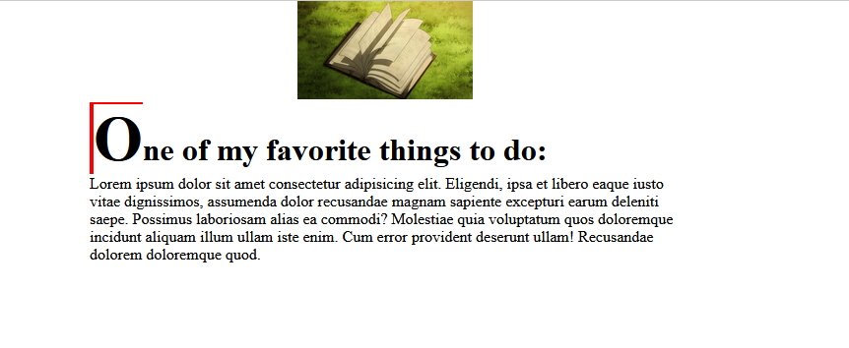
- Write a CSS rule to display the nested list items. The main category list items should be in the ordered list with property value of upper alpha and all sub category list items should be in the unordered list with property value of square.
<!DOCTYPE html>
<html lang="en">
<head>
<meta charset="UTF-8">
<meta http-equiv="X-UA-Compatible" content="IE=edge">
<meta name="viewport" content="width=device-width, initial-scale=1.0">
<style>
ol {
list-style: upper-alpha;
}
ul {
list-style-type: square;
}
</style>
<title>Document</title>
</head>
<body>
<ol>
<li>
<ul>
<li>Item1</li>
<li>Item2</li>
<li>Item3</li>
</ul>
</li>
<li>
<ul>
<li>Item4</li>
<li>Item5</li>
<li>Item6</li>
</ul>
</li>
</ol>
</body>
</html>

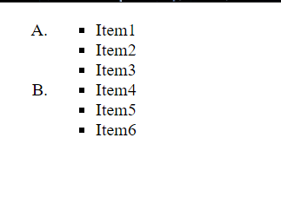
- Write the CSS following rules for the link in the web page
  - normal and visited state a background-color of #95b7cd and make their text color the same as the regular text on the page
  - links in their hover state a background-color of #aaddee
  - links in their active state a background-color of #3cc7f0
<!DOCTYPE html>
<html lang="en">
<head>
<meta charset="UTF-8">
<meta http-equiv="X-UA-Compatible" content="IE=edge">
<meta name="viewport" content="width=device-width, initial-scale=1.0">
<style>
a {
text-decoration: none;
color:#95b7cd;
}
a:hover {
color: #aaddee;
}
a:active {
color: #3cc7f0;

}
a:visited {
color: black;
}
</style>
<title>Document</title>
</head>
<body>
<p>Lorem ipsum dolor, sit amet consecteturzadipisicing elit. Quaerat, impedit commodi labore suscipit veritatis iste debitis facere praesentium blanditiis quisquam, asperiores iusto aspernatur. <a href="https://www.interviewbit.com/blog/html-css-books/">Click Here.</a> Quia voluptatem odio, reprehenderit dolore doloremque rem!</p>
</body>
</html>
- Create a text shadow on the phrase "New features in CSS3" with a horizontal offset of 2px, a vertical offset of 5px, a blur radius of 6px and a text-shadow color deepskyblue.
<!DOCTYPE html>
<html lang="en">
<head>
<meta charset="UTF-8">
<meta http-equiv="X-UA-Compatible" content="IE=edge">
<meta name="viewport" content="width=device-width, initial-scale=1.0">
<style>
.textshad {
text-shadow: 2px 5px 6px deepskyblue;
}
</style>
<title>Document</title>
</head>
<body>
<h1 class="textshad">NEW FEATURE IN CSS3</h1>
</body>
</html>


- Create a div element with a width and height of 500px. Create a diagonal linear gradient using the colors of the rainbow—Red, Orange, Yellow, Green, Blue, Indigo, Violet.
<!DOCTYPE html>
<html lang="en">
<head>
<meta charset="UTF-8">
<meta http-equiv="X-UA-Compatible" content="IE=edge">
<meta name="viewport" content="width=device-width, initial-scale=1.0">
<style>
div {
height: 500px;
width: 500px;
background: linear-gradient(45deg,red,orange,yellow,green,blue,indigo,violet);
}
</style>
<title>Document</title>
</head>
<body>
<div></div>
</body>
</html>
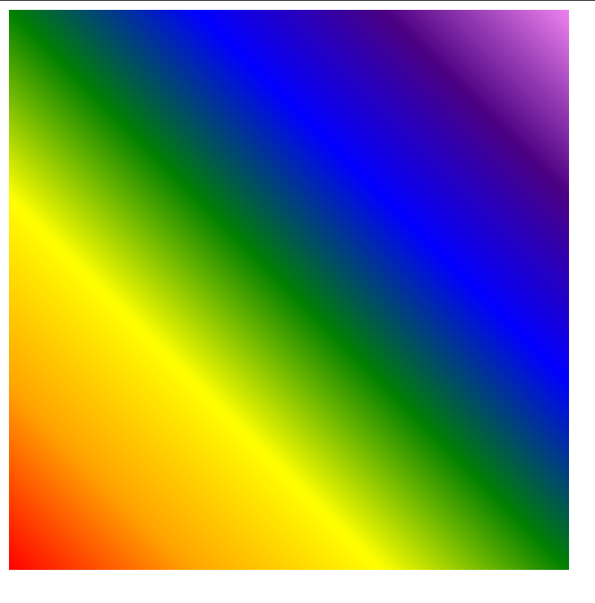
- Create a div element with a width and height of 500px. Create a radial gradient with three colors. Start the gradient in the bottom-left corner with the colors changing as they move along the gradient line to the right.
<!DOCTYPE html>
<html lang="en">
<head>
<meta charset="UTF-8">
<meta http-equiv="X-UA-Compatible" content="IE=edge">
<meta name="viewport" content="width=device-width, initial-scale=1.0">
<style>
div {
height: 500px;
width: 500px;
background: radial-gradient(skyblue,aqua,green);
}
</style>
<title>Document</title>
</head>
<body>
<div></div>
</body>
</html>


- Write the CSS code for below webpage:
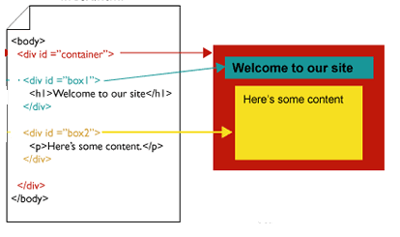
Html file
<!DOCTYPE html>
<html lang="en">
<head>
<meta charset="UTF-8">
<meta http-equiv="X-UA-Compatible" content="IE=edge">
<meta name="viewport" content="width=device-width, initial-scale=1.0">
<link rel="stylesheet" href="styles.css">
<title>Document</title>
</head>
<body>
<div id="container">
<div id="box1">
<h1>Welcome to our site</h1>
</div>
<div id="box2">
<p>Here's some content</p>
</div>
</div>
</body>
</html>

Styles.css
body{
margin: 0;
}
#container{
margin: 0;
background-color: red;
width: 100%;
height:800px;
display: flex;
align-items: center;
flex-direction: column;
justify-content: space-around;
}
#box1{

background-color: skyblue;
width: 90%;
height:100px;
display: flex;
justify-content: center;
align-items: center;
}
#box2{

background-color: yellow;
width: 80%;
height:500px;
display: flex;
justify-content: center;
}



